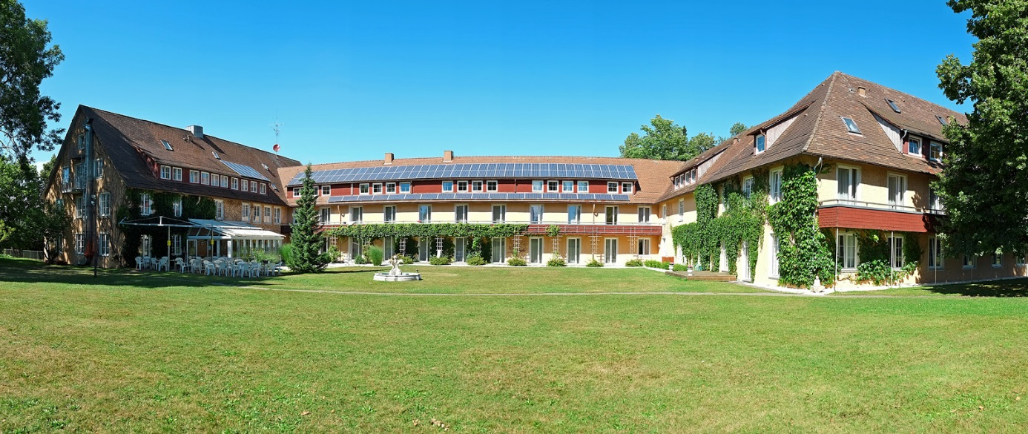
Hospitality __________________________________
Seminarzentrum Sonnenstrahl
Sebastian-Kneipp-Str. 1
88353 Kisslegg
+49 (0) 7563 1890
info@hotel-sonnenstrahl.de
www.seminarzentrum-sonnenstrahl.de

The seminar center is quiet situated and offers a wonderful park,
as well as a spa and two saunas.

Book your room directly at the hotel, via email.
After the written booking is received and processed,
you will receive a conformation of your booking.
Exceptions can be made, for example, if you don´t have access to the internet. In that case, a reservation by phone is permitted.

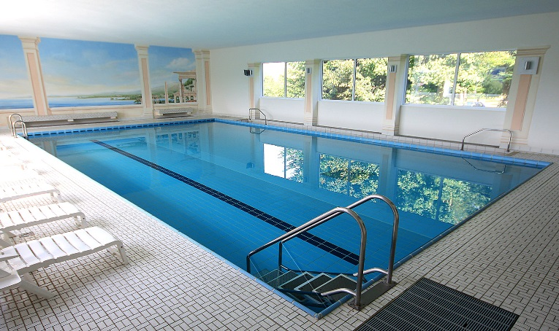

Category & prices__________________________________

Single room with private bathroom € 98,00
Double-/ twin bedroom with private bathroom € 84,00
Sonnenstrahlzimmer (large double room)
with private bathroom € 90,00
Single room with shared bathroom € 70,00
Double-/ twin bedroom with bathroom € 70,00
Dormitory € 63,00
Camping € 49,00

The prices are per day/ person including full board (buffet style, only vegetarian and vegan food).
Additionally, we charge 6,--€ per day/ person for the coffee break, as well as a local visitors tax of 1,--€ per day/ person.

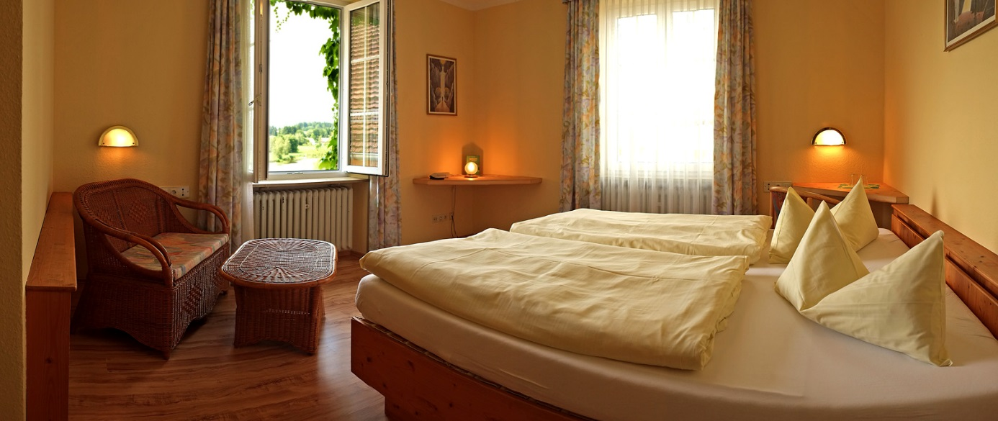

If you are not staying at the seminar centre, please contact us about the conference package for food and sanitary facilities.

